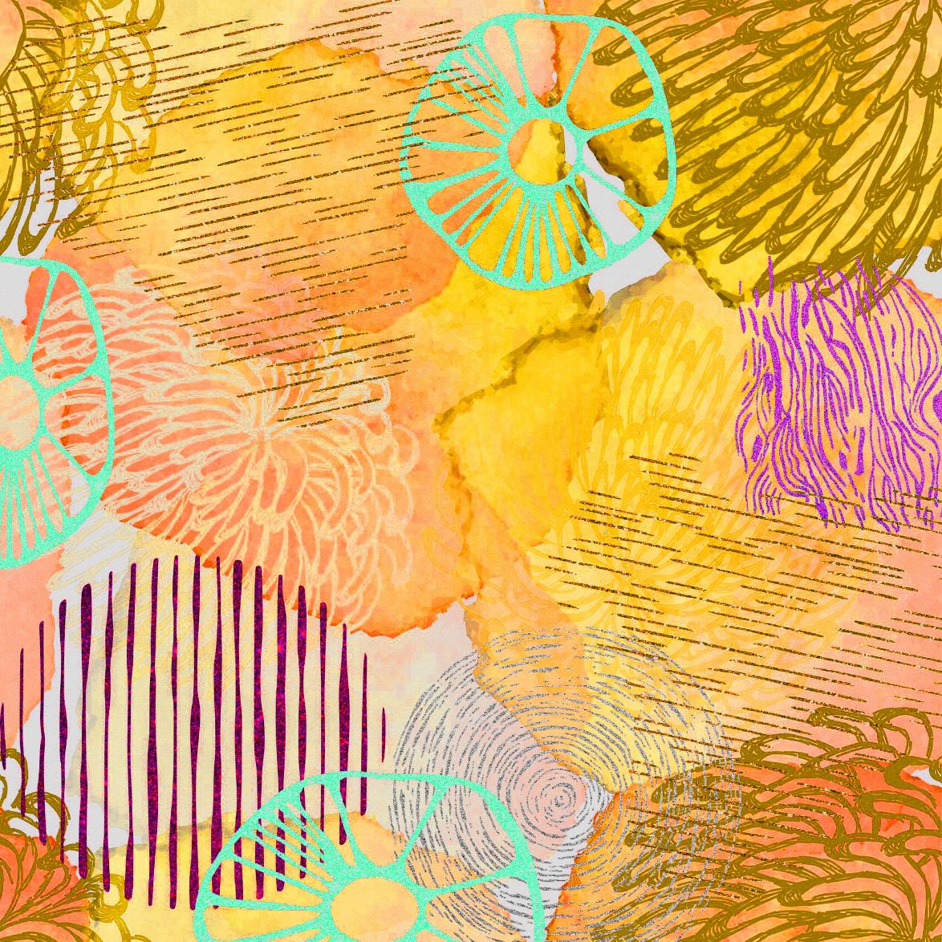

**ARTHEWE**

**Multiform Pedagogy in Arts, Health and Well-being Education**

**Creative Wellbeing as a Competence, Syllabus**

|  |  |
| --- | --- |
| Study unit/course | Creative Wellbeing as a Competence |
| Level of studies | Master’s Degree Programme |
| ECTS | 5 |
| Duration | One semester |
| Evaluation | 1-5 or passed/failed |
| Learning methods | Face-to-face and/or online learning sessions, approximately once or twice a month. Contact teaching including thematic presentations and lectures of theory, practice, and research. Pair, individual and small group work, discussions, sharing expertise and reflection.  The teaching will make use of art-based methods and the students' own specific skills. Before each contact learning session, students familiarize themselves with the subject of the learning session by doing a preliminary assignment, for example reading literature. After the learning sessions the subject is studied further through learning tasks. |
| Themes of the study module: | * understanding the knowledge base, structures, and contexts of creative well-being * identifying and understanding key concepts of creative well-being * the international development and background of creative well-being * interdisciplinary cooperation, networking, sharing of knowledge * accessibility, diversity and enabling cultural needs * the impacts of arts and culture for wellbeing and health * design of creative well-being services. |

**Competence objectives of study unit**

After completing the study module, the student will be able to:  
  
- identify and analyse the essential knowledge, areas of expertise and development tasks in the field of creative well-being  
  
- understand the concept of creative well-being at an advanced level; creative well-being as a phenomenon, as an evolving professional field, as well-being lived and experienced  
  
- understand the personal relationship to arts and culture at the core of creative well-being as a basis for the cultural needs of individuals and communities  
  
- identify and reflect on their own competence in interprofessional cooperation as well as the roles, common goals, and opportunities of different professionals in the field of creative well-being  
  
- identify and justify the meanings and dimensions of creative well-being for individuals and communities, in as part of different services and professional roles

Content of the study unit:

The course covers the core competences of creative well-being professionals and the essential knowledge, concepts, and contexts of creative well-being.  
  
The studies expand and deepen one's professional competence related to current themes of creative well-being and interprofessional work.  
  
The studies strengthen interprofessional dialogue and cooperation in the fields of social, health, education, arts, and culture to promote experiences of well-being, inclusion and meaningfulness through arts and culture as well as art-based and creative ways of working.