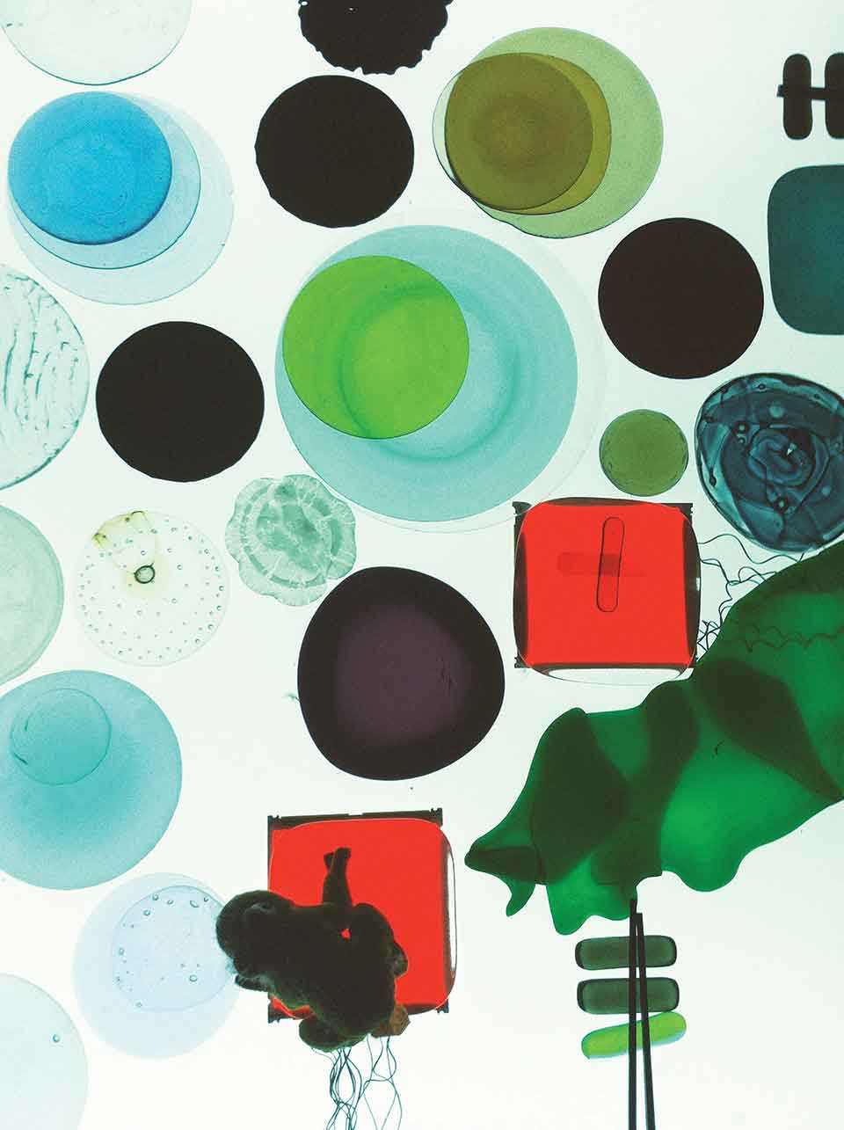





**Health and Well-being Promotion through Creative Methods**

**Syllabus**

|  |  |
| --- | --- |
|  | Health and Well-being Promotion through Creative Methods |
| Level of studies | Postgraduate |
| ECTS | 2 |
| Study period | [*To be completed by the HEI using it*] |
| Duration | One semester |
| Method | Face-to-face or blended learning |
| Objectives | * learn creative strategies for health and wellbeing promotion for different target groups in the population * learn how these strategies can be implemented within different health and wellbeing promotion interventions at individual and community level |
| Students’ evaluation | Active participation in the course and final assignment. Grading system is based on pass or fail. |

Background

According to W.H.O, Health Promotion is the process of enabling people to increase control over, and to improve their health (WHO, 1998). Health is created and lived by people within the settings of their everyday life; where they learn, work, play and love.

Creativity is described as a vital part of making creative things and define it as the innate ability to think and act with real sources, to be inventive and imaginative and to find new and real solutions for the needs, the issues and expression forms (Hansen et al., 2020). Creative methods are seen as a vehicle for someone’s self-expression (Müllersdorf & Ivarsson, 2016) whereas they make a significant difference on people’s health and wellbeing (Cameron et al., 2013). Some methods of creativity are: Photography, Ceramics, Dance, Games, Sculpture, Drawing and Music (University of the Arts, 2021).

Interventions including creativity approaches allow participants to feel pride, reflect, have sense of belonging, improve owns skills, self-esteem, satisfaction and rest (Müllersdorf & Ivarsson, 2016; Pollanen, 2013; Bellamy, 2018). There are several benefits gained by creative based interventions that have been supported in the literature. For example, improved physical and mental well-being, (Clift, 2012), social integration (Tymoszuk et al., 2021), improved coping abilities, better body understanding (Jensen & Bonde, 2018; Gillam, 2018), increased in positive feelings, relief, relaxation, concentration, motivation and increased energy (Hansen et al., 2020; Murphy et al., 2020), changes on beliefs and behavior, increased self-esteem and confidence, drug abuse reduction, increased interpersonal development skills and self-empowerment were also documented (Bungay & Burrows, 2013; Mbizvo, 2006).

Learning outcomes

At the completion of the course, students will:

- know the concepts of health and well-being promotion and how they may be defined in different contexts

- be aware of the participatory approach and co-production in health and well-being promotion

- develop their critical thinking and creativity

- know several creative methods that can be used in health and well-being promotion interventions

- be able to use creative methods and integrate them in health and well-being promotion interventions

- be able to work effectively in teams

- improve their communication skills and their English language skills

Content

- Revision of the concept of health promotion and the methodology of planning, implementing and evaluating health and well-being promotion interventions

- Participatory and co-production approaches in health and well-being promotion

- Creative methods in health and well-being (e.g. (digital) storytelling, visual arts, drama/theatre, dance)

- Creative methods in the evaluation of the health and well-being promotion interventions

- Examples of good practice among different population target groups

- International case studies

Learning resources and activities

The following are suggested as learning resources and activities of this course according to each HEI and students’ group needs:

- Online asynchronous learning platform - eLearning material for self-study

- Lectures

- Group work

- Creative workshops (developing a poem, an art work, etc.)

- Students’ presentations

Course evaluation

Different approaches can be used for the evaluation of this course, such as:

- Online questionnaire - feedback (listening to music while filling in the questionnaire)

- Evaluation café

- Drawings

Students’ evaluation and grading system

Students will be evaluated through their active participation in the course and a final assignment which will be presented orally in classroom (or virtual classroom) at the end of the course. Grading system is based on pass or fail. This course leads to 2 ECTS.

Relevant literature

Alexander, S.A., Frohlich, K.L., & Fusco, C. (2014). Playing for health? Revisiting health promotion to examine the emerging public health position on children's play. *Health Promotion International, 29*(1), 155-164. <https://doi.org/10.1093/heapro/das042>

Bellamy, R. (2018). Creative health promotion methods for young LGBTIQA+ people. *Health Education Journal, 77*(6), 680-691. <https://doi.org/10.1177/0017896917753454>

Bungay, H., & Burrows, T. (2013). The effects of participating in creative activities on the health and well-being of children and young people: a rapid review of the literature. *Royal Society of Public Health, 133*(1), 44-52. <https://doi.org/10.1177/1757913912466946>

Bunn, C., Kalinga, C., Mtema, O., Abdulla, S., Dillip, A., Lwanda, J., Mtenga, S.M., Sharp, J., Strachan, Z., & Gray, C.M. (2020). Arts-based approaches to promoting health in sub-Saharan Africa: a scoping review. *BMJ Global Health, 5*, e001987. <https://doi.org/10.1136/bmjgh-2019-001987>

Cameron, M., Crane, N., Ings, R., & Taylor, K. (2013). Promoting well-being through creativity: how arts and public health can learn from each other. *Royal Society of Public Health, 133*(1), 52-59. <https://doi.org/10.1177/1757913912466951>

Clift, S. (2012).Creative arts as a public health resource: moving from practice-based research to evidence-based practice. *Royal Society of Public Health, 132*(3), 120-127. <https://doi.org/10.1177/1757913912442269>

Darewych, O.H., & Bowers, N.R. (2018). Positive arts interventions: creative clinical tools promoting psychological well-being. *International Journal of Art Therapy, 23*(2), 62-69. <https://doi.org/10.1080/17454832.2017.1378241>

Daykin. N., Gray, K., McCree, M., & Willis, J. (2017). Creative and credible evaluation for arts, health and well-being: opportunities and challenges of co-production. *Arts & Health, 9*(2), 123-138. <https://doi.org/10.1080/17533015.2016.1206948>

Fraser, K.D. & Sayah F. (2011). Arts-based methods in health research: A systematic review of the literature. *Arts & Health, 3(*2), 10-145. <https://doi.org/10.1080/17533015.2011.561357>

Fuller, C.W., Junge, A., DeCelles, J., Donald, J., Jankelowitz, R., & Dvorak, J. (2010). 'Football for Health'--a football-based health-promotion programme for children in South Africa: a parallel cohort study. *British Journal of Sports Medicine, 44(*8), 546-554. <https://doi.org/10.1136/bjsm.2010.072223>

Gillam, T. (2018). Enhancing public mental health and wellbeing through creative arts participation. *Journal of public mental health, 17*(4), 148-156. <https://doi.org/10.1108/JPMH-09-2018-0065>

Hansel, B., Erlandsson, L., & Leufstadius, C. (2020),A concept analysis of creative activities as intervention in occupational therapy. *Scandinavian Journal of Occupational Therapy,*28(1), 63-77. <https://doi.org/10.1177/1757913918772602>

Jaganath, D., Mulenga, C., Hoffman, R.M., Hamilton, J., & Boneh, G. (2014). This is My Story: participatory performance for HIV and AIDS education at the University of Malawi. *Health Education Research, 29*(4), 554–565. <https://doi.org/10.1093/her/cyt074>

Jensen, A., & Bonde, L.O. (2018). The use of arts interventions for mental health and wellbeing in health settings*. Perspectives in Public Health, 138*(4), 209-214. <https://doi.org/10.1177/1757913918772602>

Kok, D.J., Bisschops, I., Knoop, L., Tulu, L., Kujawa-Roeleveld, K., Masresha, N., & Houtkamp, J. (2020). Game over or play again? Deploying games for promoting water recycling and hygienic practices at schools in Ethiopia. *Environmental Science & Policy, 111*, 83-90. <https://doi.org/10.1177/1757913918772602>

Mansfield, L., Daykin, N., & Kay, T. (2020) Leisure and wellbeing. *Leisure Studies, 39*(1), 1-10. <https://doi.org/10.1080/02614367.2020.1713195>

Mbizvo Ε. (2006). Theatre—a force for health promotion. *Lancet 2006, 368*, 30-31. <http://doi.org/10.1016/S0140-6736(06)69917-0>

McKay, F.H., & McKenzie, H. (2018). Using Art for Health Promotion: Evaluating an In-School Program Through Student Perspectives. *Health Promotion Practice, 19*(4), 522-530. <https://doi.org/10.1177/1524839917735076>

Müllersdorf, M., & Ivarsson, A. (2016). What, Why, How – Creative Activities in Occupational Therapy Practice in Sweden. *Occupational Therapy International, 23*(4), 369-378. <https://doi.org/10.1002/oti.1438>

Murphy, K.J., Swaminathan, S., Howard, E., Altschuler, A., Rogan, J., Beauchet, O., Dupuis, K., Galea, L.A.M., Hogan, D., Lingum, N., Rowe, G., Tsotsos, L., Szczepura, A., Wittich, W., Xie F., & Hasher, L. (2020). Accessible Virtual Arts Recreation for Wellbeing Promotion in Long-Term Care Residents. *Journal of Applied Gerontology*, 40(5), 519-528. <https://doi.org/10.1177/0733464820967195>

Pollanen, S. (2013).The meaning of craft: Craft makers’ descriptions of craft as an occupation. *Scandinavian Journal of Occupational Therapy, 20*(3), 217–227. <https://doi.org/10.3109/11038128.2012.725182>

Psomos, P., & Kordaki, M. (2015). A Novel Educational Digital Storytelling Tool Focusing on Students Misconceptions. *Procedia - Social and Behavioral Sciences, 191*, 82-86. <https://doi.org/10.1016/j.sbspro.2015.04.476>

Roberts, M., Lobo, R., & Sorenson, A. (2017). Evaluating the Sharing Stories youth theatre program: an interactive theatre and drama-based strategy for sexual health promotion among multicultural youth. *Health Promotion Journal of Australia, 28*(1), 30-36. <https://doi.org/10.1071/HE15096>

Slattery, M., Attard, H., Stewart, V., Roennfeldt, H., & Wheeler, A.J. (2020). Participation in creative workshops supports mental health consumers to share their stories of recovery: A one-year qualitative follow-up study. *PLoS ONE, 15*(12), e0243284. <https://doi.org/10.1371/journal.pone.0243284>

Todd, C., Camic, P.M., Lockyer, B., Thomson, L.J.M., & Chatterjee H.J. (2017). Museum-based programs for socially isolated older adults: Understanding what works*. Health & Place, 48*, 47–55. <https://doi.org/10.1016/j.healthplace.2017.08.005>

Tymoszuk, U., Spiro, N., Perkins, R., Bertrand, A., Gee, K., & Williamon, A. (2021).Arts engagement trends in the United Kingdom and their mental and social wellbeing implications: HEartS Survey*. PLoS ONE, 16(*3), e0246078. <https://doi.org/10.1371/journal.pone.0246078>

University of the arts (2021). *Undergraduate programs*. <https://www.uarts.edu/academics/undergraduate-programs>

White, M. (2006). Establishing common ground in community-based arts in health. Journal of the Royal Society for the Promotion of Health, 126(3): 128-133. <https://doi.org/10.1177/1466424006064302>

W.H.O. (1998). *Health Promotion overview*. Health Promotion Glossary. <https://www.who.int/health-topics/health-promotion#tab=tab_1>

W.H.O. (2018). Promoting health: Guide to national implementation of the Shanghai Declaration. <https://apps.who.int/iris/bitstream/handle/10665/260172/WHO-NMH-PND-18.2-eng.pdf;jsessionid=6E08A3CE367496C323C66CEE3E1EAC45?sequence=1>

Zeilig, H., Killick, J., & Fox, C. (2014). The participative arts for people living with a dementia: A critical review. *International Journal of Ageing and Later Life, 9*(1), 7–34. <https://doi.org/10.3384/ijal.1652-8670.14238>

Relevant peer reviewed journals

Arts & Health

Journal of Applied Arts & Health

Canadian Review of Art Education

Leisure Studies

Creativity Research Journal

Nordic Journal of Arts, Culture and Health

International Journal of Art Therapy

Journal of Arts and Communities

Health Education Journal

Health Education Research

Health Promotion International

Health Promotion Journal of Australia

Health Promotion Practice

Journal of the Royal Society for the Promotion of Health